Steps to launch a Windows machine on our system
using the RDP protocol
-------------------------------------------------------------------------
Step-1
- Open and login to the AWS console.
- Search EC2 service in AWS.
- Click on that Lunch Instance Button.
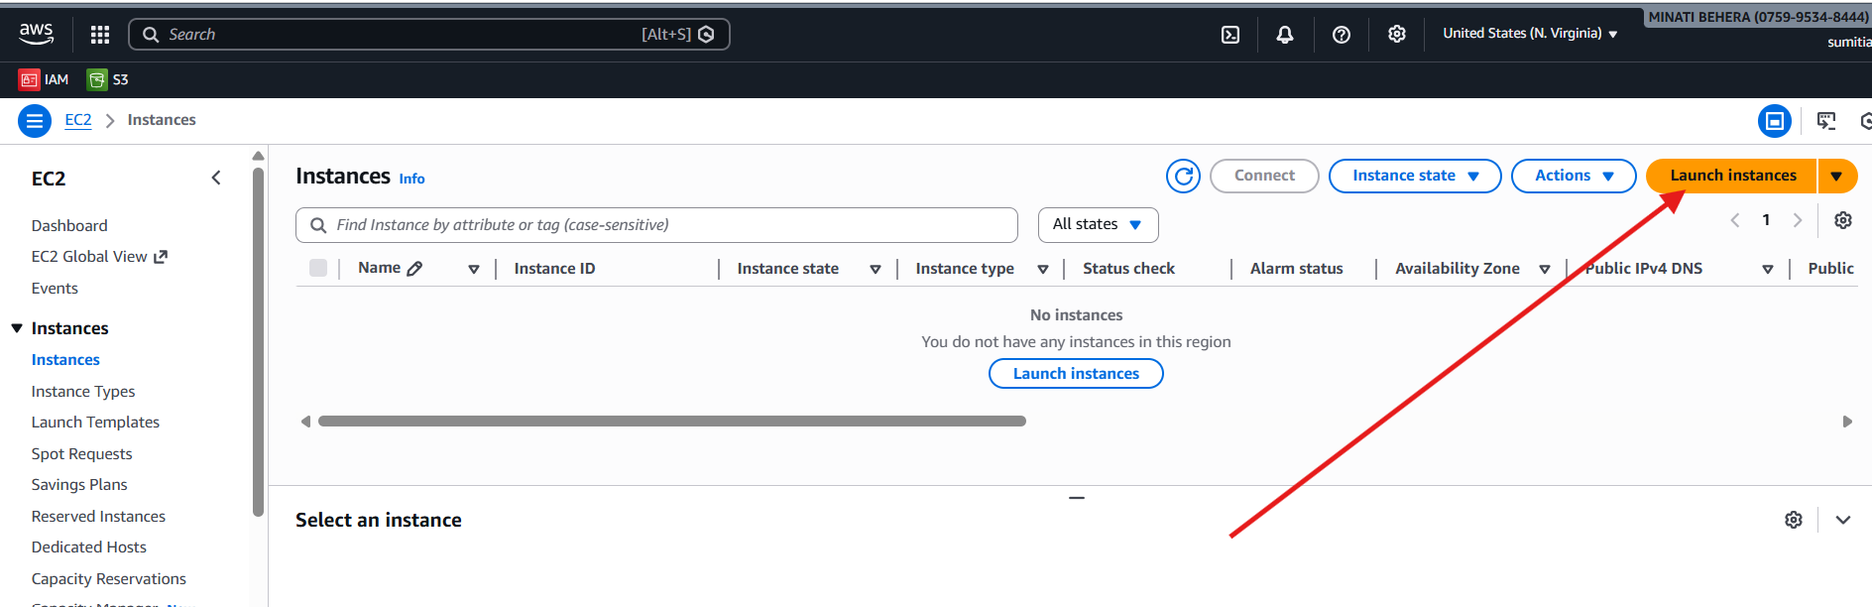

- Give an unique Instance name.
- An select an AMI(Amazon Machine Image) provided by the AWS and select the free tire.
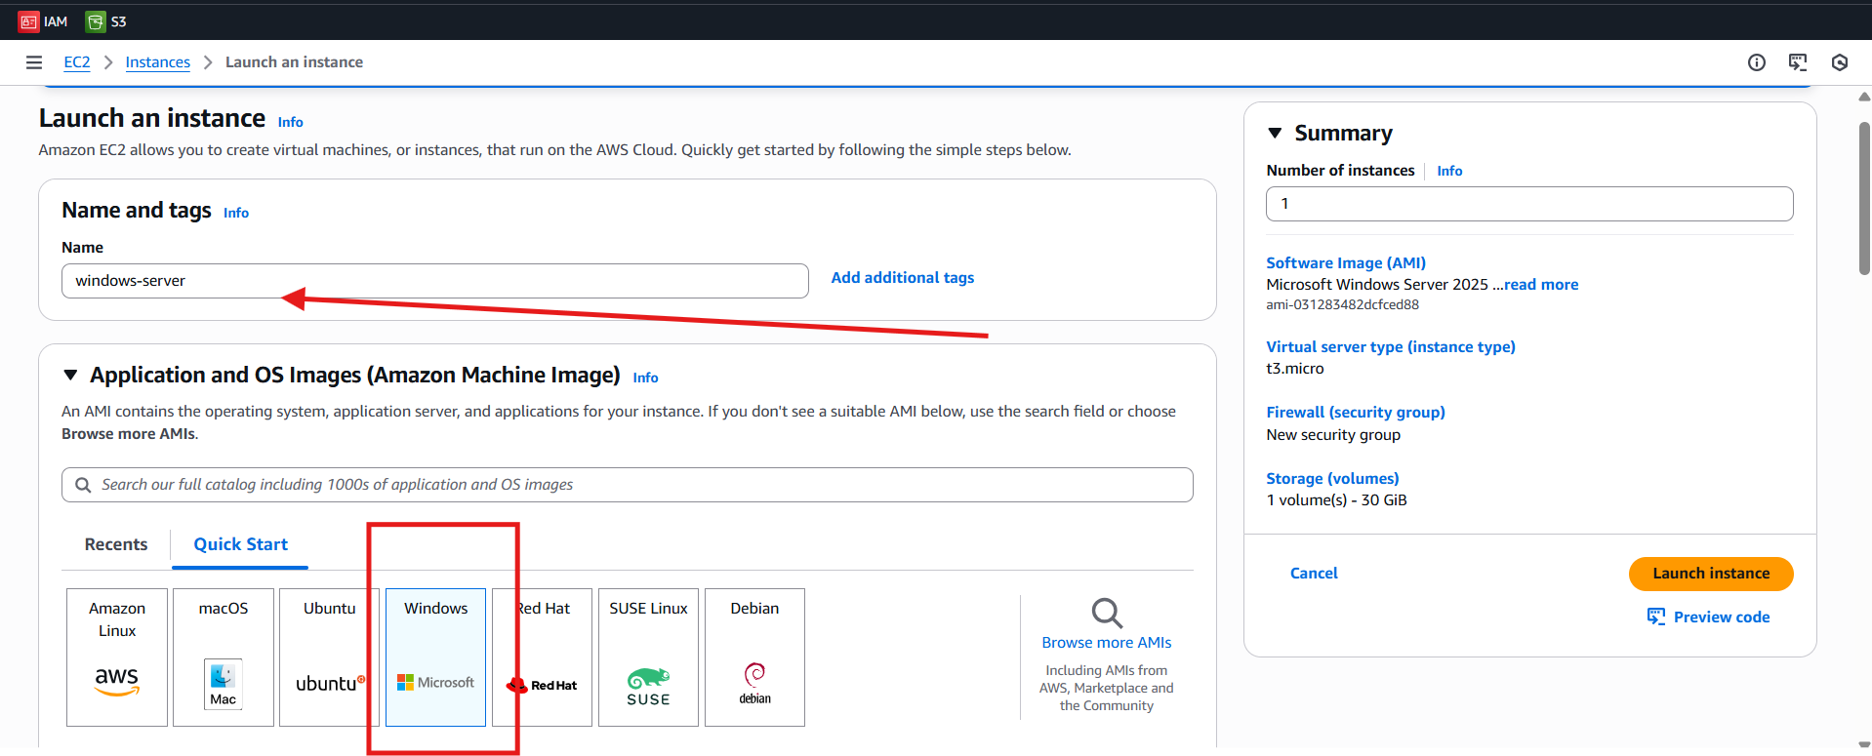
- Now choose Key Pair if don’t have a key pair then create it or else use the existing key pair.
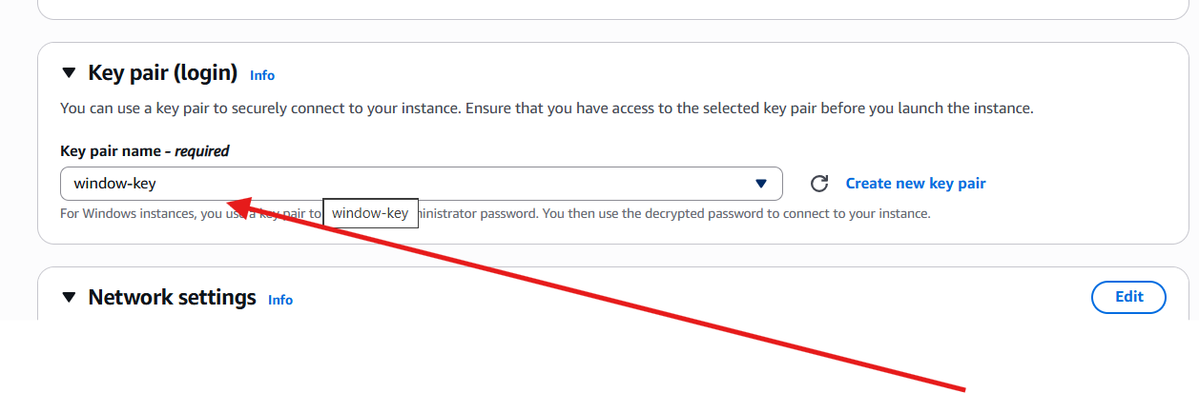
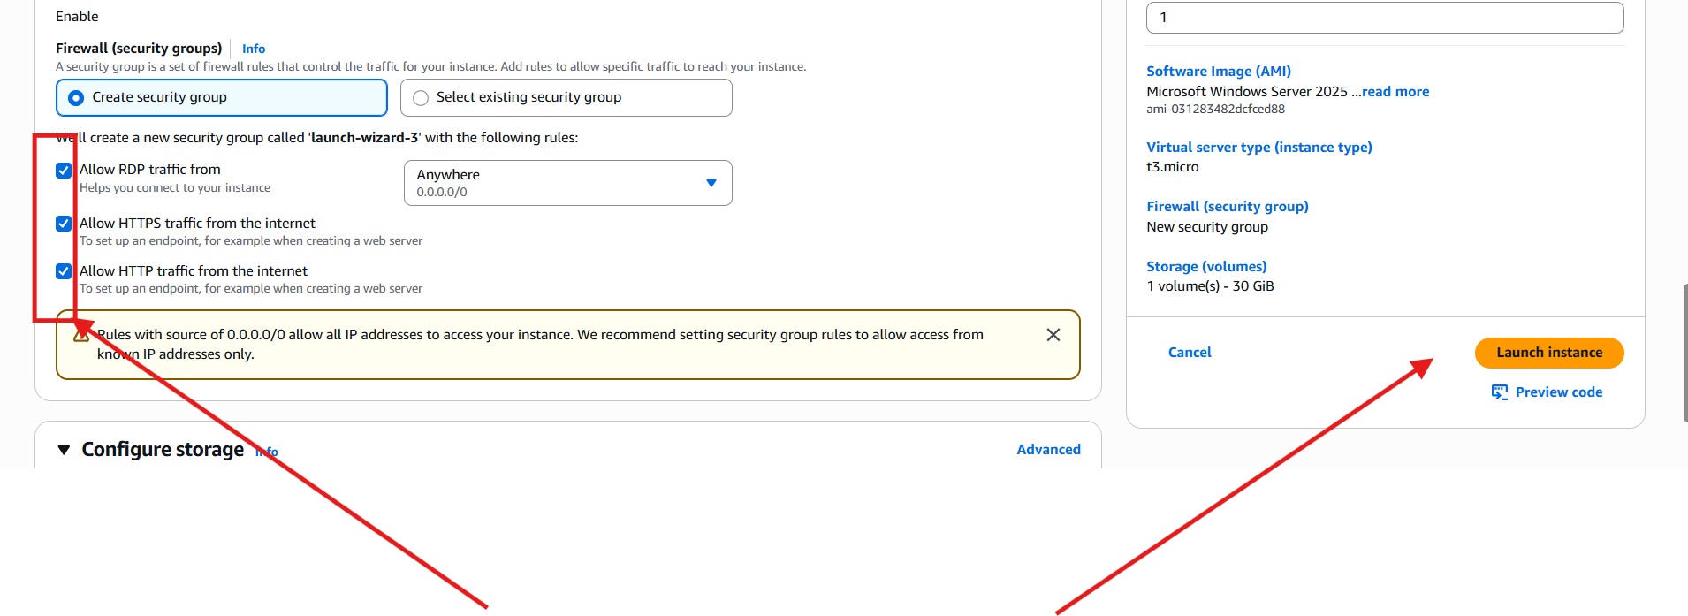

Step-2
i)Connect with Instance
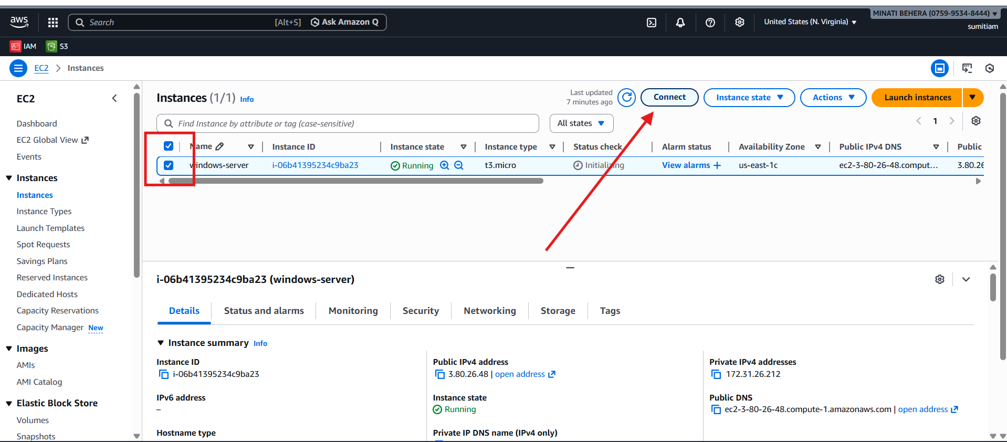

ii)Click on RDB client
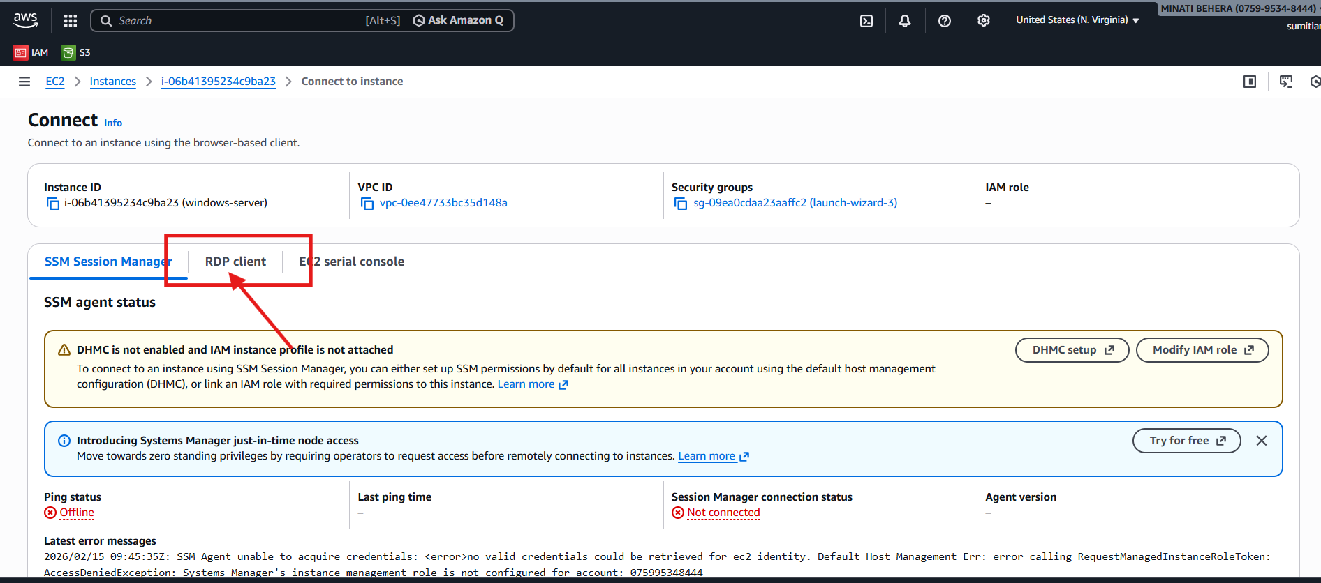
iii)Click on get password
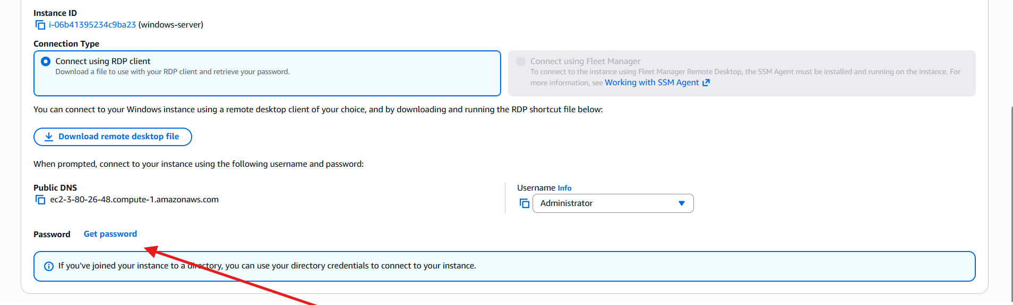
iv)Upload
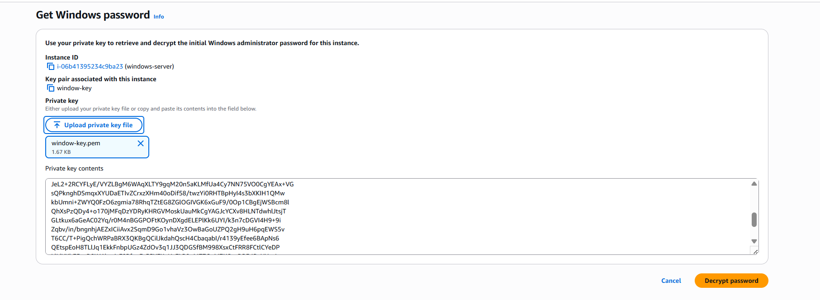

v)copy the Id Password ,Public DNS and Password
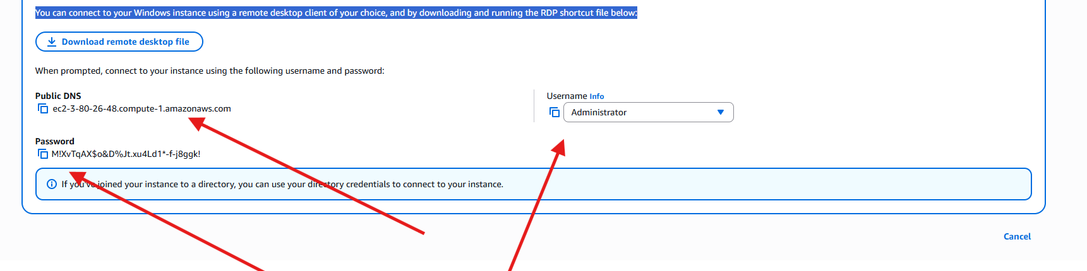
Step-3
i)Open Remote Desktop Connection
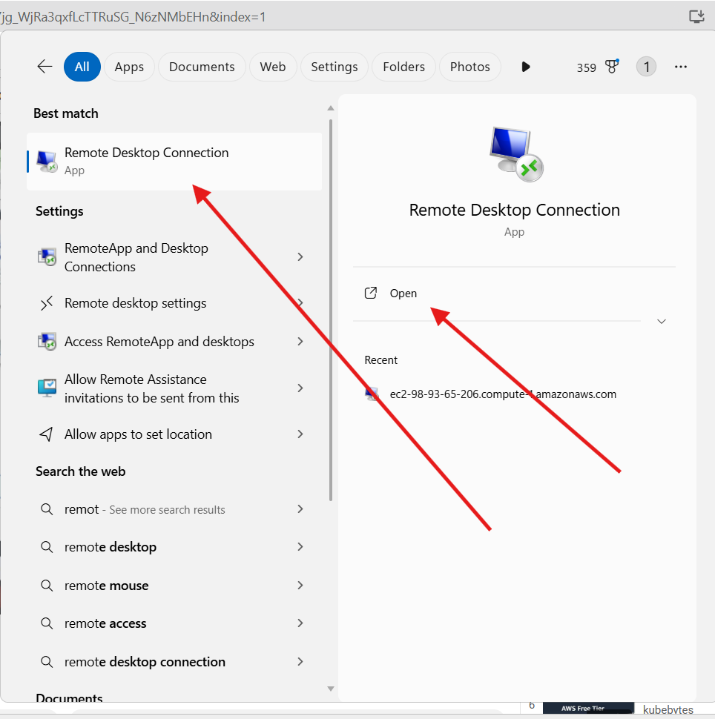

ii)Set the computer name as Public DNS
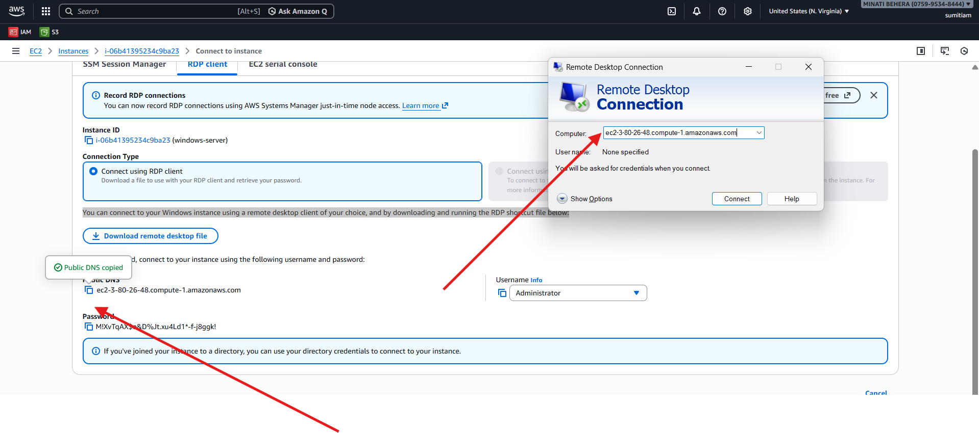
iii)Set User name
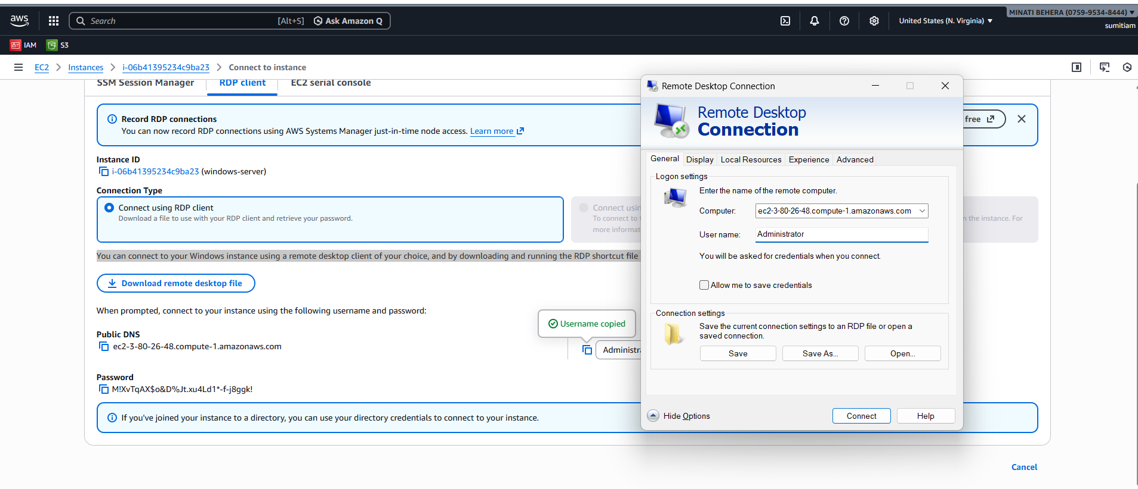
iv)After putting password we can successfully loged into our new windows
